Language Translator

Project Proposal

Utilizing text to speech recognition services the language translator translates various foreign language text or voice input into English.

Use Cases:

1. Locals that want to enhance their vocabulary.
2. Translate Spanish to English and hear its pronunciation.
3. Pick from a variety of source to destination languages.

|  |
| --- |
| **Functional Requirements:** |
| The App will allow a user to input text into an edit text that will be translated into English translation text. |
| The App shall respond with feedback for invalid vocabulary. |
| User shall pick from a list of source languages (including but not limited to Spanish and Italian) to translate into English. |
| The App shall bring up the right keyboard for the source language. |
| The App shall provide audio of correct pronunciation of translated word |
| The APP shall have user permissions to use internet services such as frengly.com |
| The APP shall have permissions to use on-board hardware. |

|  |
| --- |
| **Non Functional Requirements:** |
| The app shall recognise voice of source language and translate it to textual destination language. |
| The app should provide an option from the home screen for either speech translation or textual translation. |
| The App shall store a list of translated words in a list View for future reference. |

**On board hardware Requirements:**

On board Phone speaker with the permissions:

<uses-permission android:name="android.permission.MODIFY_AUDIO_SETTINGS" />

On board Phone speaker with the permissions:

<uses-permission android:name="android.permission.MODIFY_AUDIO_SETTINGS" />

(Optional) On board microphone:

<**uses-permission** android:name="android.permission-group.MICROPHONE"/>

**API’s Used:**

**www.frengly.com**

[POST] http://frengly.com/frengly/data/translateREST

{

src: 'en',

dest: 'fr',

text: 'this is a sample text in english',

email: 'xxx@xxx.com',

password: 'xxx',

premiumkey: 'yyy'

}

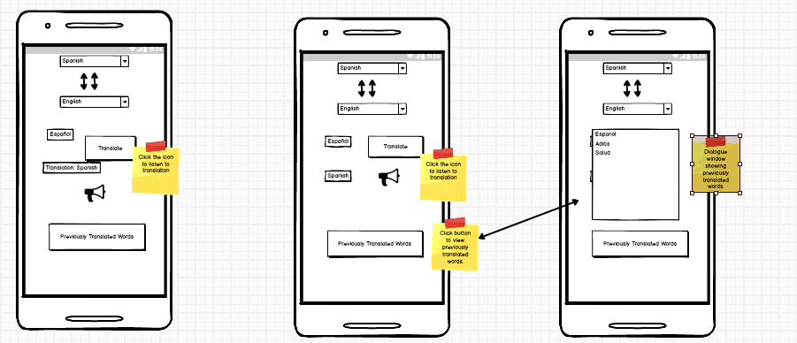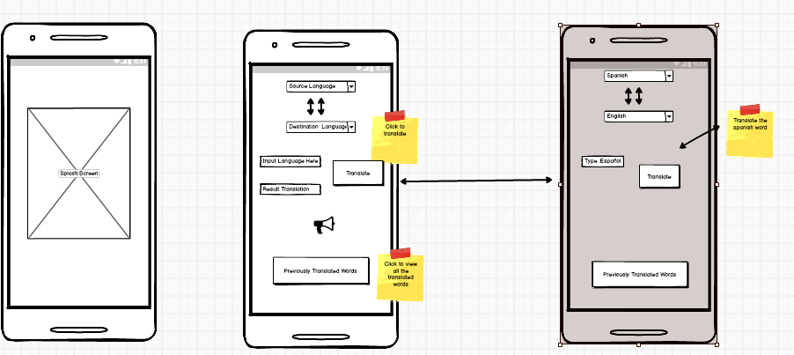Wire Frames